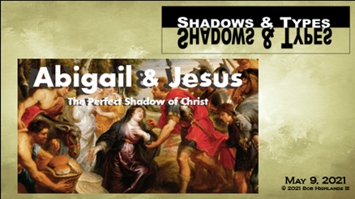
Week Three – Study Guide
Abigail and Jesus
This week you have six shadows to figure out and to give as much information as you can. Some are obvious and simple others may need you to think.
#1. Text 1 Samuel 25.20; John 12:14-15 (quoting Zechariah 9:9)

(BONUS: Why would kings of Israel ride on donkeys instead of warhorses? See 1 Kings 1.33. Other instances of leaders riding donkeys are Judges 5:10; 10:4; 12:14; and 2 Samuel 16:2.)

#2. Text 1 Samuel 25.25; Jeremiah 4.22; 1 Corinthians 1.27

#3 This isn’t exactly a type or shadow but it is worth looking at. How is the statement of Abigail about David also applicable to Jesus?
Text 1 Samuel 25.28b-31; Hebrews 3.3; John 19.6; 1 Corinthians 15.25-25

#4 Text 1 Samuel 25.32; 1 Timothy 2.5

#5 Text 1 Samuel 25: 33-34; 1 Thessalonians 5:9; Romans 3.25 (see also Hebrews 2:17, 1 John 2:2, and 1 John 4:10)
The word propitiation is a religious word which has a two-part meaning:
- Turning away the wrath of an offended individual
- Providing reconciliation as a result. (Remember what we learned on Sunday about reconciliation and what it involves.

#6 Text 1 Samuel 25.39-41; John 13.1-17

(Bonus: what key spiritual truths do we as followers of Christ learn from Abigail and Jesus here?)

