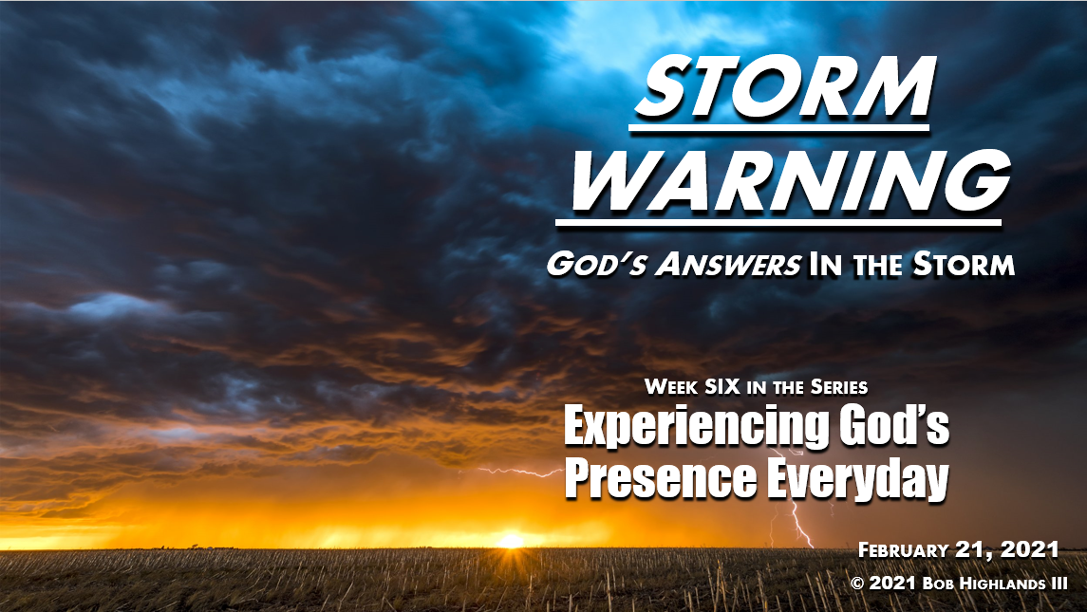
John 6.6-21
All Types of Storms

♦ Meanwhile, the disciples were in trouble far away from land, for a strong wind had risen, and they were fighting heavy waves. Mt. 14.24 NLT
♦ When you are in _______________
♦ Health, Wealth & Happiness are upside down and _______________is out of whack.
♦ Far from LAND
♦ There is no _______________in sight
♦ There is Strong _______________
♦ PROGRESS seems _______________
♦ FIGHTING heavy waves
♦ You are _______________and there is no __________

Surviving the Storms
♦ They had rowed three or four miles when suddenly they saw Jesus walking on the water toward the boat. They were terrified… Jn 6.19 NLT
♦ 3 or 4 miles: How _________ do you have to row before help comes, before there is an answer? How long is not mentioned.
♦ _______________is never when or what we expect it to be. What we figure out in our heads is never how it works out.
♦ The _______________is often more terrifying than the storm when we first see it. People often reject the answer because it scares them to death.

The Daniel Delay Paradox
♦ but he called out to them, "_________ ______ ___________. I AM here!” Jn 6.20 NLT
♦ _______________was walking on the water toward the boat in the storm. The answer was coming to them.
♦ The ______________________________does not mean He is not answering, it just means the answer is on the way. KEEP _______________!
♦ See Daniel 10.4-19 for whole incident.
♦ "_________ ______ ___________, Daniel.” This is the message He has for all of us no matter what storm we are in. God keeps repeating it over and over.

The ANSWER
The one who formed you says,
"DO NOT BE AFRAID, for I have ransomed you.
I have called you by name; you are mine.
When you go through deep waters,
I will be with you.
When you go through rivers of difficulty,
you will not drown.
When you walk through the fire of oppression,
you will not be burned up;
the flames will not consume you.
For I AM the LORD, your God,
the Holy One of Israel, your Savior. Isa. 43.1-2

DO Not Fear Because
♦ I have _____________ you
♦ You _____________ to Jesus Now!
♦ WHEN _____________ happens
♦ Passing through _____________ Waters
♦ Go through rivers of _____________
♦ Pass through fire of _____________ you will make it without burn or being consumed by the flames.
♦ _____________ I AM
♦ the _____________ = He is in charge so trust
♦ your _____________ = Heavenly Father
♦ Your _____________ = The one who rescues

Storms: Take Away for Today
♦ There are all types of storms and they _____________ be avoided in life, Sorry.
♦ The first key to surviving storms is to not give up and _____________ _____________ .
♦ No matter how long the delay _____________ BE _____________ the answer is on the way.
♦ _____________ the I AM , ransomed you, you belong to HIM and HE will help you…
♦ through _____________ Waters
♦ through rivers of _____________
♦ Pass through fire of _____________
♦ Storms _____________ : “and immediately they arrived at their destination!”

